**GoService – Complaint & Service Request Management System**

**Industry**

Public Services / Smart City Governance

**Project Type**

B2C & B2G (Citizen → Government Department) Salesforce CRM Implementation

**Target Users**

* Citizens (raise complaints & track status)
* Department Staff (Education, Transportation, Health, Environment, etc.)
* Supervisors / City Managers (monitor resolution & efficiency)

**Problem Statement**

City residents frequently face issues such as potholes, broken streetlights, garbage collection delays, and poor public service responses. Currently:

* Complaints are scattered across phone calls, emails, and in-person visits.
* No centralized tracking exists, leading to delays and repeated complaints.
* Citizens lack transparency in complaint resolution progress.
* Supervisors struggle to monitor service efficiency across departments.

To solve this, the municipality wants to implement Salesforce CRM to:

* Automate complaint capture from web, mobile, and social channels.
* Categorize complaints by department and urgency.
* Assign tasks automatically to the right teams.
* Provide real-time dashboards for supervisors and management.
* Enhance citizen satisfaction through timely updates.

# Phase 1: Problem Understanding & Industry Analysis

**1. Requirement Gathering**

Functional Requirements:

* Citizens should be able to log complaints via a web form / mobile portal.
* Complaints should be categorized (Education, Transport, Health, Environment, etc.).
* The system should automatically assign complaints to the right department queue.
* Agents should update complaint status (New → In Progress → Resolved → Escalated).
* Supervisors should monitor SLA compliance and overdue complaints.
* Automatic notifications via email/SMS for updates.
* Reports & dashboards for city managers.

Non-Functional Requirements:

* System must handle high complaint volumes (scalability).
* Secure citizen data (PII protection).
* SLA-based performance metrics.
* Integration with SMS/email service.

**2. Stakeholder Analysis**

Citizens

* Role: End users who log complaints.
* Needs: Easy complaint submission & real-time tracking.

Department Staff (Agents)

* Role: Resolve complaints assigned to them.
* Needs: Task queue, service request scheduling, resolution updates.

Supervisors / Managers

* Role: Monitor staff performance & SLA compliance.
* Needs: Dashboards, reports, escalation visibility.

City Administrators (Govt Officials)

* Role: Strategic decision makers.
* Needs: High-level complaint trends & citizen satisfaction metrics.

**3. Business Process Mapping**

Current State (Manual):

* Citizen calls/visits office → Complaint written in registers.
* Agent assigned manually → Often delayed or lost.
* No central tracking → Citizens keep following up.
* Reports created manually → Errors and delays.

Future State (With Salesforce):

1. Complaint Submission: Citizen submits via form (Experience Cloud portal).
2. Auto-Categorization: Based on complaint type.
3. Assignment: Auto-assigned to queues/groups via Flows.
4. SLA Monitoring: Timer starts, escalates if overdue.
5. Resolution: Agent updates complaint status & adds notes.
6. Citizen Updates: Automatic SMS/email sent.
7. Reporting: Dashboards show resolution rates, pending complaints, SLA breaches.

**4. Industry-Specific Use Case Analysis (Public Services / Smart City)**

* Pain Point in Industry: Citizens often feel ignored due to lack of transparency in complaint resolution.
* Industry Goal: Improve citizen trust, efficiency of service delivery, and compliance with SLAs.
* CRM Advantage: Salesforce provides a centralized platform with automation, reporting, and mobile accessibility.

Examples of real-world relevance:

* Municipal corporations in India (like Bengaluru, Pune Smart City) use similar systems.
* International cities use Salesforce Service Cloud for citizen complaint management.

**5. AppExchange Exploration**

SMS Integration Apps:

* Twilio SMS for Salesforce
* Vonage SMS for Salesforce

Survey & Feedback Apps:

* Survey Force (for citizen feedback).

Field Service Apps:

* Field Service Lightning (for visit-based complaint resolution).

Other Utilities:

* Document management apps for storing proof of complaint.

# Phase 2: Org Setup & Configuration

In this phase, the Salesforce environment (Org) was set up and configured to support the foundation of the Complaint Management System. The objective was to establish the org structure, user hierarchy, security model, and access controls before building custom objects and automation.

**1. Salesforce Edition & Org Setup**

A Developer Edition Org was used for the implementation.

* Company Name: GoService Pvt. Ltd.
* Default Time Zone: (GMT+05:30) India Standard Time (Asia/Kolkata)
* Default Currency: INR
* Default Locale & Language updated accordingly.

**2. Business Hours, Holidays & Fiscal Year**

* Configured business hours (Mon–Fri, 9 AM – 6 PM) for complaint resolution SLAs.
* Added a sample holiday list (e.g., National Holidays) to simulate downtime.
* Fiscal year was set to standard fiscal year (Jan–Dec).

**3. User Roles (Hierarchy)**

Roles were created to represent the hierarchy of users within the system:

* System Administrator (Top): Full org-wide visibility and control.
* Supervisor (Reports to Admin): Can see all complaints of staff in their team.
* Department Staff (Reports to Supervisor): Handles and resolves complaints assigned to them.
* Citizen (Lowest level): External user who can log their own complaints but cannot see others’ records.

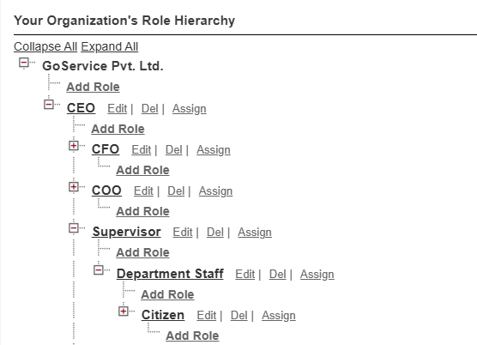

This ensures role hierarchy data visibility: Supervisor > Staff > Citizen.

**4. User Profiles**

Profiles were created by cloning standard profiles to control object-level permissions.

1. Citizen Profile (cloned from Customer Community Plus User): Minimal access; can only create and view their own complaint records.
2. Department Staff Profile (cloned from Standard User): Can view and update complaints assigned to them.
3. Supervisor Profile (cloned from Standard User): Additional reporting and dashboard access, plus View All on complaints.
4. System Administrator Profile (default): Full access to all setup and records.

**5. User Licenses & Users Created**

Licenses were assigned to different types of users:

* Citizen User
  + License: Customer Community Plus
  + Role: Citizen
  + Profile: Citizen Profile
  + Username: citizen@goservice.com
* Department Staff User
  + License: Salesforce
  + Role: Department Staff
  + Profile: Department Staff Profile
  + Username: staff@goservice.com
* Supervisor User
  + License: Salesforce Platform
  + Role: Supervisor
  + Profile: Supervisor Profile
  + Username: supervisor@goservice.com
* Admin User
  + License: Salesforce (System Administrator)
  + Role: System Administrator
  + Profile: System Administrator
  + Username: [bhishan.cd22645@agentforce.com](mailto:bhishan.cd22645@agentforce.com)

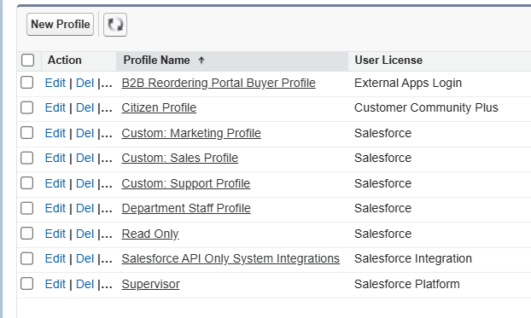

**6. Organization-Wide Defaults (OWD)**

Configured OWD sharing settings for data security:

* Complaint Object (planned for Phase 3) → Private
* Role hierarchy ensures supervisors can see staff complaints, while staff cannot see each other’s records.

**7. Sharing Rules & Login Access**

* Sharing rules not yet created (will be configured once objects are ready).
* Login access policies updated to allow Admin control over all users for troubleshooting.